The development of cryptographic protocols such as QUIC and TLS represents a major advancement in the security of digital communications. But there is always a risk due to the legacy of vulnerabilities, especially those from outdated standards like PKCS#1 v1.5. Even with advances in cryptographic algorithms designed to improve online security, several weaknesses; specifically in the padded encrypted messages allow for unintended data leakage. This is known as Padding Oracle Attacks which gives malicious parties the ability to spoof or decrypt communications sent through secure channels.

**Overview**:   
Oracle attacks use a "padding oracle" to determine whether the padding in encrypted messages is legitimate. These attacks have the potential to break secure communications in the context of TLS and QUIC because they make it possible for attackers to forge signatures or decrypt messages without requiring the private key.

**The Padding Oracle Attack Mechanism**:  
Oracle Attacks take advantage of a server's response to cipher texts that have been carefully constructed. This feedback allows attackers to deduce the encryption key or the plaintext. This frequently occurs due to error messages linked to padding validation. The vulnerabilities found in TLS 1.3 and QUIC protocols recently highlight how resilient Oracle Attacks are in the face of evolving security standards.

**TLS 1.3 Protocol**:

While explicit padding is not part of the TLS 1.3 protocol by design, implementations that support old modes or include certain features that are backward-compatible may unintentionally generate padding oracle vulnerabilities. First, an attacker intercepts encrypted communication passing between a server and a client. After that, they make changes to the intercepted ciphertext and send it again to the server, monitoring the server's reply.  
  
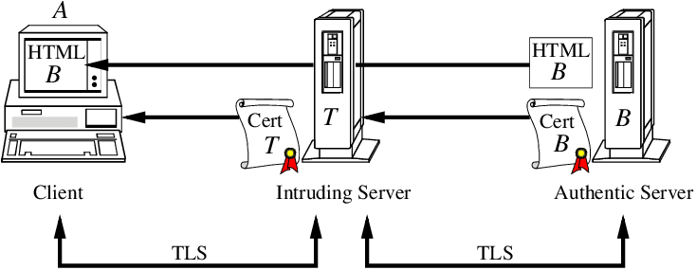  
  
In response to the altered ciphertext, the server may process the request and indicate the correct padding, or it may return an error and indicate the incorrect padding. An attacker can progressively uncover the plaintext by altering and resending various versions of the ciphertext and examining the server's answers.  
  
**Mitigation**:  
TLS 1.3 implementations need to take care not to send out distinct error messages that could be used as an oracle. Additionally, timed attacks that take use of the padding oracle can be lessened by switching to constant-time processing for cryptographic operations.

**The QUIC Protocol**:  
QUIC protocols are designed with encryption built-in, as opposed to TCP-based protocols that depend on TLS for security. By reducing latency and optimizing encryption and decryption procedures, QUIC's architecture may provide new possibilities for oracle attack padding.

The packet number and header are encrypted by QUIC, which reduces the amount of manipulated clear text for an attacker. Nevertheless, there may still be flaws in the way payload data encryption and packet integrity are handled. Like the TLS padding oracle attack, an attacker might try to modify encrypted QUIC packets in order to obtain distinct replies from the server. They would especially want to concentrate on the encrypted payload, which contains the application data.  
  
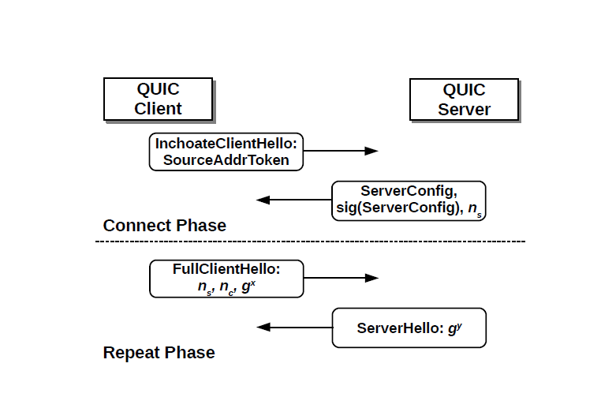  
There are two main stages to the QUIC protocol that handle connection management:

Connect Phase: Forms a fresh link between client and server, settling on security guidelines and encryption keys to ensure safe correspondence.

Repeat Phase: Skips the initial handshake processes and resumes sessions using the existing connection parameters, allowing for faster reconnections and data transmission.

**Mitigation**:  
It is critical for QUIC to make sure that every part of the packet, including the headers and packet numbers, is encrypted in a way that prevents side channel disclosure of payload information. Similar to TLS 1.3, it is crucial to use constant-time operations and steer clear of recognizable faults when processing encrypted data.

**RSA Encryption and PKCS#1 v1.5**A pair of keys is needed for both encryption and decryption when using the popular asymmetric algorithm known as RSA encryption. Data is encrypted using the public key and decrypted using the private key. The padding strategy for RSA encryption is specified in PKCS#1 v1.5, and it is essential to ensure the security of encrypted messages.  
Every ciphertext is distinct because to the non-deterministic padding method used to the plaintext prior to encryption in PKCS#1 v1.5. This method makes sure that identical messages encrypt to different ciphertexts, preventing plaintext attacks.

**Vulnerabilities**:  
The padding technique in PKCS#1 v1.5 has been proven to be susceptible to oracle attacks, which allow an attacker to gradually extract the plaintext from the ciphertext by taking advantage of a system's processing of decryption errors, despite the method's intended design.

TLS and QUIC may inherit the issue if RSA encryption in accordance with PKCS#1 v1.5 is used for key exchange or data encryption. This would enable attackers to decrypt traffic or forge signatures without having access to the private key.  
  
**Mitigation and Recommendations**:  
The vulnerabilities related to PKCS#1 v1.5 can be mitigated by implementing RSA-PSS which is a more secure signature scheme that is associated with PKCS#1 v2.2. Ensuring that TLS and QUIC implementations are up-to-date and correctly configured to use secure protocols and algorithms is critical for preventing attacks that exploit legacy vulnerabilities. Preventing attacks that take advantage of outdated vulnerabilities requires making sure that TLS and QUIC implementations are current and set up correctly to employ secure protocols and algorithms.

**References**

* Fedler, R. (2013). Padding Oracle Attacks. Seminar Innovative Internet Technologies and Mobile Communications, Technische Universität München.
* IETF. (2018). The transport layer security (TLS) protocol version 1.3. RFC 8446.
* Vaudenay, S. (2002). Security flaws induced by CBC padding—Applications to SSL, IPSEC, WTLS... In International Conference on the Theory and Applications of Cryptographic Techniques (pp. 534-545). Springer.
* Bleichenbacher, D. (1998). Chosen ciphertext attacks against protocols based on the RSA encryption standard PKCS #1. In Advances in Cryptology—CRYPTO’98 (pp. 1-12). Springer.
* GlobalPlatform. (2018). GlobalPlatform Card Specification Version 2.3.1.
* ISO/IEC 10116:2017. Information technology—Security techniques—Modes of operation for an n-bit block cipher.
* ISO/IEC JTC 1/SC 27. (2011). ISO/IEC 9797-1:2011—Information technology—Security techniques—Message Authentication Codes (MACs)—Part 1: Mechanisms using a block cipher.
* Aviram, N., Schinzel, S., Somorovsky, J., Heninger, N., Dankel, M., Steube, J., ... & Dukhovni, V. (2016). DROWN: Breaking TLS using SSLv2. In 25th USENIX Security Symposium.
* Rizzo, J., & Duong, T. (2012). The CRIME attack.
* J. Ziv and A. Lempel. (1977). A universal algorithm for sequential data compression. IEEE Transactions on Information Theory, 23(3), 337-343.
* N. J. Al Fardan and K. G. Paterson. (2013). Lucky Thirteen: Breaking the TLS and DTLS Record Protocols. In 2013 IEEE Symposium on Security and Privacy (pp. 526-540).